**Summar Training Project Report**

On

**“Web Technologies”**

Submitted as a part of course curriculum for

**B.TECH**

**in**

**CSE(ARTIFICIAL INTELLIGENCE AND MACHINE LEARNING)**

**MAHARAJA RANJIT SINGH PUNJAB TECHNICAL UNIVERSITY**

**BATHINDA**



**Submitted To: Submitted By:**

Simardeep Kaur Ansh Gupta

CSE(AIML) 4th Sem

231950007

**ACKNOWLEDGEMENT**

A work without the blessings and guidance of elders is always half done and unsatisfactory. The task of completing the project needs cooperation and guidance of prominent persons in the subject line. My abundant and most sincere thanks to honorable project guide **Simardeep Kaur** for providing me with the necessary facilities to carry out the project successfully.

**Place:** Bathinda **Signature**

# 

**TABLE OF CONTENTS**

**CHAPTER NO. TITLE**

Title Page ………………………………

Declaration ……………………………..

Certificate ………………………………

Acknowledgement……………………….

**1**   **INTRODUCTION………………………**

1.1 Project Overview……………………..

1.2 Objectives & Scope……………………

**2. SYSTEM STUDY AND ANALYSIS…..**

2.1 System Analysis…………….

2.2 System Design…………………

**3. FEASIBILITY STUDY…………………..**

**4**.  **H/W & S/W REQURIMENTS…………..**

**5. THE INTERNET………………………..**

5.1 Origin of Internet……………………..

5.2 Benefits of Internet &E-Mail…………

**6 HTML FUNDAMENTALS……………**

6.1 Origin of HTML………………………

6.2 Application of HTML…………………

6.3 Principles of HTML…………………..

6.4 Types of HTML Tags………………….

6.5 Document TAGS………………………

6.6 Paragraph TAGS………………………

6.7 Formatting Documents…………………

6.8 List TAGS………………………………

6.10 Tables & Frames……………………….

6.11 HTML Forms…………………………..

6.12 Style Sheet………………………………

**7. ABOUT PROJECT LINKS……………**

**8. SCREENSHOTS…………………………**

**9. BIBLOGRAPHY…………………………**

**Chapter: 1**

**1.1 INTRODUCTION AND OVERVIEW OF THE PROJECT**

**Project Title:** E-Learning System

**Project Category:** Web Based Applications

Today is competitive world. Everything is going to be online. For this our first requirement is a platform, an interface through which we can interact with world, and that can become possible through a website.

So keeping in view the need of hour, our project is on website development. We have developed the website of E-Learning System. Front end is HTML.

In today’s competitive environment, service innovations are re-defining accepted levels of performance. A good Management System is one of the crucial requirements for successful organizations when managing students’ needs and protecting their interests.

Like any other project, a web site begins as a concept. The website has purposes providing the information about E-Learning System. The goal is to spread information about the brief knowledge about Networking Components. The goal is very broad, such as creating an online presence to build name recognition and Prestige for a city website and making sure to work out right approach I plan to take in achieving that goal.

###### 1.2 OBJECTIVES & SCOPE OF PROJECT

It helps to measure customer satisfaction and is a useful source of information and feedback for improving services. Often customers are the first to identify when things are not working properly.

**Implementing effectively helps in: -**

* Improves Center internal information handling
* Reduces recurring complaints
* Improves standards of service to the community
* Raises standards of administrative decision-making

**The following objectives have been set:**

* Smooth flow of data without any hurdles.
* Adequate validation checks for data entry.
* Adequate security of data.
* Facility to update data from time to time.
* Prompt and specific retrieval of data.
* Flexibility in the system according to the changing environment.
* Controlling redundancy in storing the same data multiple times.
* Accuracy, timeliness and comprehensiveness of the system output.
* Stability and operability by people of average intelligence.

**Features**

* **Easy to maintain data-**Through this software the process of the maintaining the record of students, teachers are quite faster and are done at the fast pace.
* **Easy to retrieve the data-** With the help of listing facility available the retrieval of data is very fast and easy.
* **Fast updating-** In the proposed system the modifications on the records can be done very easily and at fast pace.
* **Centralization of the data-**All the data would be stored in the database and so keeping and storing of records is easy.
* **Resource Saving-**lot of manpower and hours are saved and paperwork is reduced.

**Implementing effectively helps in: -**

* Improves Center internal information handling
* Reduces recurring complaints
* Improves standards of service to the community
* Raises standards of administrative decision-making

**Chapter: 2**

**2.1 SYSTEM ANALYSIS**

Planning information systems in business has become increasingly important during the past decade. First information is now recognized as a vital resource and must be managed .It is equal in importance to cash, physical facilities and personnel. Second more and more financial resources are committed to information systems. As computer systems are becoming integral to business operations, top management is paying more attention to their development. Third there is a growing need for formal long range planning with information systems that are complex, require months or years to build, use common data bases or have greater competitive edge.

**Needs Identification**

The success of a system depends largely on how accurately a problem is defined, thoroughly investigated and properly carried out through the choice of solution. User need identification and analysis are concerned with what the user needs rather than what he wants. Not until the problem has been identified, defined and evaluated should the analyst think about solutions and whether the problem is worth solving.

**Project Definition and Project Initiation**

The first step in an initial investigation is to define the problem that led to user request .The problem must be stated clearly, understood and agreed upon by the user and the Analyst. It must state the objectives the user is trying to achieve and the results the user wants to see. Emphasis should be on the logical requirements.

Given user identification of need, the analyst proceeds to verify the problem by separating symptoms from causes. For example are not the problem per but are the symptoms of staff shortage, a manual procedure that does not revive the customer information for clearance or both. The latter reason is the problem.

**Background Analysis**

Once the project is initiated, the analyst begins to learn about the setting the existing system and the physical processes related to the revised system. Therefore the analyst should prepare an organization chart with a list of functions and people who perform them.

2.2 **SYSTEM DESIGN**

System design goes through two phase of development: logical and physical design. For a candidate system it describes the inputs, outputs, databases and procedures- all in a format that meets the user requirements. When analysts prepare the logical system design, they specify the user needs at a level of detail that virtually determines the information flow into and out of the system and the required data resources.

**1**. Reviews the current physical system –its data flows, file content, volumes, frequencies.

**2**. Prepares output specifications- that are it determines the format, content and frequency of reports, including terminal specifications and locations.

**3**. Prepares input specifications- format, content and most of the input functions. This includes determining the flow of the document from the input data source to actual input location.

**4**. Prepares edit, security and control specifications- This includes specifying the rules for edit correction, back up procedures and the controls that ensure processing and file integrity.

**5**. Specifies the implementation plan.

**6**. Prepare a logical design walkthrough of the information flow, output input and implementation plan.

**7**. Reviews benefits, cost, target dates and system constraints.

Following logical design is physical design. This produces the working system by defining the design specifications that tell programmers exactly what the candidate system must do. In turn the programmer writes the necessary programs or modifies the software package that accepts input from the user, performs the necessary calculations through the existing file or database, produces the report on a hard copy or displays it on a screen and maintains an updated data base at all times. Specifically physical design consists of the following steps.

**Design the physical system.**

**a**. Specify input/output media.

**b**. Design the database and specify backup procedures.

**c**. Design physical information flow through the system and a physical design walkthrough.

**Plan System implementation**.

**a.** Prepare a conversion schedule and a target date.

**b.** Determine training procedure, courses and timetable.

**c**. Devise a test and implementation plan and specify any new a hardware /software.

**d**. Update benefits, costs, and conversion date and system constraints.

**Chapter: 3**

**3.1 FEASIBILITY STUDY**

Three key considerations are involved in the feasibility analysis: economic, technical Behavioral. Let’s briefly review each consideration and how it relates to the systems effort.

## (I) Economic feasibility

Economic analysis is the most frequently used method for evaluating the effectiveness of a candidate system. More commonly known as cost/ benefit analysis the procedure is to determine the benefits and savings that are expected from a candidate system and compare them with the costs. If benefits through outweigh costs, then the decision is made to design and implement the system. Otherwise, further justification or alterations in the proposed system will have to be made if it is to have a chance of being approved.

# **(I I) Technical feasibility**

Technical feasibility centers on the existing computer system (hardware, software, etc.) and to what extent it can support the proposed addition. For example if the current computer is operating at 80 percent capacity –an arbitrary ceiling-then running another application could overload the system or require additional hardware. This involves financial considerations to accommodate technical enhancements.

**(III) Behavioral Feasibility**

People are inherently resistant to change and computers have been known to facilitate change. An estimate should be made of how strong a reaction the user staff is likely to have toward the development of a computerized system. It is common knowledge that computer installations have something to do with turnover, transfers and changes in employment job status. Therefore it is understandable that the introduction of a candidate system requires special effort to educate, sell, and train the staff on new ways of conducting business.

**3.2 Advancement for Future:**

* **Extensible:**

**User can do easily extend anything into the project .**

* **Modification:**

**They can do any modification into the project as they needed.**

* **Upgradeable:**

**After modification of the project it can be easily upgrade by the used.**

* **Maintain Database:**

**User can maintain the database according the current status of the company & it can be easily modify.**

**Chapter: 4**

**4 HARDWARE AND SOFTWARE REQUIREMENTS**

**4.1 HARDWARE REQUIREMENTS**

* Pentium Dual Core Processor
* 1 GB of RAM
* 20 GB of hard disk

**4.2 SOFTWARE REQUIREMENTS**

* HTML
* DHTML (CSS)

**Chapter: 5**

**5 THE INTERNET**

**WHAT DOES IT MEAN?**

A network can be any system carrying interactive information. In context to computers i.e. when we say computer network then it is a group of computers that are connected together for sharing information and resources.

As such there is no single standard definition for Internet. Definition varies depending on the user who uses it for various purposes.

**Different ways in which Internet can be stated are:**

It is a huge Wide Area Network used for communication and extracting information.

It is a place for making commercial and business analysis.

It is a channel to visit different places virtually.

All of these explanations are right but no one of these is complete.

The term Internet has been originated from two terms Interconnection and Networks. So the Internet can be described as the network formed by the interconnection of several computing networks. In other words it is a network of networks. The Internet comprises of thousands of computers, connected globally by different mediums. The different medium of connection can be fiber optics, phone lines, and satellite links and so on. So, in nutshell it can be described as a collection of computers, connecting millions of computers all over the world.

**5.1 Origin of Internet:**

The United States Department of Defense (DOD) created a network in 1969 known as Arpanet. The Arpanet model helped the researchers to communicate with each other. ARPA’s (Advanced Research Project Agency) main task was to develop a reliable and geographically dispersed network for military purposes

.

The concept behind the Arpanet was, splitting the data into small packets, which in turn could travel through different routes to their destination. With this type of mechanism the network could partial destruction, as the data packets would take different routes to their respective destination. With the creation of Arpanet in 1970s other various networks like Bitnet, Usenet, came into existence. In 1980s the NSFC (National Science Foundation Corporation) created a network called NSFNET. They connected their super computer to research agencies and universities to facilitate effective communication among them. In 1990s some of the pioneering networks were dismantled and all other independent network joined with the NSFNET. In 1990s some of the pioneering networks were dismantled and all other independent network joined with the NSFNET.

**5.3 Benefits of Internet**

You can do a number of things on the Internet like communicating with others around the world, operating Bank Accounts etc. On an average, on any given day, the Internet connects more than 30 million users over 100 countries. Broadly, we can categorize the different applications of the Internet as follows:

Communication on the Internet

Electronic Mail (e-mail)

Conferencing/Chatting

Internet Newsgroups

Searching/Retrieving information

FTP (File Transfer Protocol)

ARCHIE

GOPHER

VERONICA

Remote Login

**5.4 WWW (World Wide Web)**

The World Wide Web is the most popular service on the Internet for getting desired information. It should not be confused with the collection of networks, but in fact it is the information that is connected or linked/together forming a web. The WWW computer system consists of number of computers known as Web Servers. The documents or pages stored in a web server are known as Web Pages. Any web page on web can be linked to other web pages. The most common language use to create web pages is known as HTML (Hyper Text Markup Language). A user can view the information on web page using a program called Web Browser. Examples of Web browsers are Netscape Navigator, Microsoft Internet Explorer and Mosaic. A web page can simply be a block of text, but generally includes multimedia contents as well.

**5.5 Electronic Mail (e-mail)**

As the name suggests this concept is related to the mail service using electronic medium e.g. computers. It is one of the most popular services available on the Internet. Using e-mail, any user on Internet can send text-messages, pictures, sounds or even audio-video files to other users on Internet. To identify any user on Internet, there is a unique address for every user using this service. For instance: rishurahul2@rediffmail.com

**Chapter: 6**

**6 HTML FUNDAMENTALS**

The term HTML stands for Hypertext Markup Language. It is a markup language used mainly for creating web documents. HTML is quite easy to learn and use. If you look closely to each part of its name you will find the name (HTML) more meaningful.

First, by the term **Hyper** means that something this is active. So in this context i.e. in web document it simply means that if you would like to view something on a web document, then you can move immediately to it without following any set order.

The second term **Text** points to the text file you will be dealing with in HTML.

HTML has its own formatting commands commonly known as **tags** or **elements**. These tags are used to markup the contents of web pages.

The term **Markup** comes from the fact that, HTML is used to markup the contents of web pages.

By the term **Language** we mean that you will be dealing with a language along with all its syntax (in HTML you can call them tags.)

**NOTE:** You must know that HTML is not a full-fledged programming language like BASIC, etc. It is a markup language used to create web documents.

**6.1 ORIGIN OF HTML**

HTML was neither conceived from scratch not it was invented separately. It is an extended version of **SGML (Standard Generalized Markup Language).** SGML was initially used to create layouts for official documents by U.S. Department of Defense. Tim Burners Lee designed the very first HTML document in 1990 at CERN, Switzerland. Later on Dan Connolly along with other volunteers worked for further development of HTML. They wrote a brief HTML specification along with HTML document Type.

HTML has been in use on the World Wide Web right from its evolution in 1990. HTML is generally referred as a subset of SGML. HTML evolved in different levels, each being improved than the previous level. We will discuss the different levels later in this chapter.

**6.2 APPLICATION OF HTML**

As mentioned in the first session, HTML is a language mainly used to create web documents. HTML can also be used to display any document that is available on the web. The HTML elements mark-up the document and inform the browser that how the page should look like, when seen in the browser. HTML provides tags, which make the document look attractive. Hence using HTML one can deliver different kind of information in different forms to people all over the world on the web.

HTML allows the creation of hyperlinks to other documents. These connected documents may exist on some other machines. More importantly, it is a platform independent language. By platform independent we mean that document written in HTML can be viewed on any computer that runs on any operating system.

**6.3 PRINCIPLE OF GOOD DESIGNING**

* Your ultimate aim as a web-page designer should produce simple and attractive web pages. So let us see some of the points to be taken care of by the web designers while creating web pages.
* Your web page should be simple and well organized. The appearance of the web page should not confuse the user. He or she should be able to easily locate the information for which they have visited your web page.
* You should use proper color combination on your web page. The color combination should not create any problem for the user while going through (i.e. the user reading the contents of) the web pages.
* The background and other textures should not distract the user instead the user should find your page interesting.
* Always use appropriate backgrounds and images related to the text present on the web pages.
* There must be proper space between the contents present on the web page.
* The size of object on the page must be appropriate.
* These tips can give a sensible and good look to your web page.

**6.4 TYPES OF HTML TAGS ARE:**

* Container Tag
* Empty Tag

**Container Tag**:

Container tag has a starting as well as an ending tag. They can hold the text as well as other elements between two tags.

**Syntax**: <tag> TEXT </tag>

**Empty Tags:**

An empty element does not have an ending tag. For example: <HR>. It will draw a horizontal line.

**Note:** The HTML elements like <HTML> and <HR> are written inside ‘<’ and ‘>’ brackets.

**6.5 DOCUMENT TAGS**

**HTML Tag:** An HTML document starts with <HTML> tag and ends with the tag </HTML>. It is necessary for all the HTML pages to have <HTML> tag which signifies the beginning of

an HTML document and </HTML> indicates the end of the HTML document.

**Head Tag:** The <HEAD> tag is used to denote the heading of the web page. So whatever is written in between <HEAD> and </HEAD> identifies the properties of the entire page.

After <HEAD> there is yet another basic tag <Title>. The tag <Title> and </Title> is used to give a title to the HTML document. Title of the document describes the content of the page. So it is important to give a page an appropriate title. Whatever you write in between <title> and </title> tags, will appear on the title bar of the browser window.

**BODY Tag**: The <BODY> tag contains the contents of the web page. It is the area where most of the work is done. The contents in between <BODY> and </BODY> tags a displayed in the browser window. Here we can enter the text & graphics for the web page.

**Note:** HTML is not a case sensitive language i.e. <HTML> or <html> are the same. By writing the tags either in upper case or lower case does not result to any error.

**Paragraphs and Shadow Lines:**

In HTML document, the blank space between the words, in line and blank lines in a source document are ignored when displayed by a web browser. There are advantages as well as disadvantages attached to this feature of the web browser. The advantage is that lines get formatted automatically by removing extra spaces & disadvantage is that whenever you wish to mark the beginning of new line or paragraph, you have to use the HTML tags for producing these effects.

**6.6 Paragraph Tag:**

The <P> tag tells the browser to leave a blank line and begin a new paragraph. Now when the browser interprets this tag, it displays a blank line and the text following the <P> is displayed on the next line.

**Horizontal Rule** (<HR> Tag):

In order to draw a line across the page <HR> tag is used. This tag puts a line commonly called as Shadow Line, on the web page.

**Attributes:**

The properties, which are used with the tags, are called Attributes. For instance in case of <P> tag, you can use <P align=center>. Here align is used to position (center, right, left, justify) the paragraph.

Similarly for <HR> tag, you can use <HR width=”80%” size=5 color=red> for manipulating the size and color of shadow line.

**Line Break:**

We may require the line breaks in our web pages. The <BR> tag is used to separate the lines. This tag acts in the same way as the ENTER key on your keyboard. BR stands for Break Row. The <BR> tag actually tells the browser to go to the beginning of the next line so that the text following the tag <BR> is placed there.

**6.7 FORMATTING DOCUMENT**

**Headings:**

The header tags are used in HTML documents to display heading. Header tags are used to manipulate the size of the heading i.e. they make your heading larger or smaller according to the tag used. There are six header tags in HTML from H1 to H6. The H1 produces the largest size heading and H6 produces the smallest size heading.

**Basic Formatting Tags:**

There are some tags in HTML that allows you to perform basic formatting of the text in a HTML document. Basic formatting tags mainly include:

**BOLD TAG:**

In order to bold some text in your web page, HTML provides <B> tag. To get the ‘BOLD’ effect, just place text in between <B> and </B> tag.

**ITALIC TAG:**

The italic tag <I> is used in HTML to get the italic effect in your web page. It can be applied by just placing the text in between the opening <I> and closing </I> tag.

**UNDERLINE TAG:**

By using the tag <U>, you can underline any text of your web document.

The various other formatting tags with their effects are:

|  |  |
| --- | --- |
| Tag Name | Effect |
| <em> --- </em> | Emphasis the text usually in italic. |
| <q> --- </q> | Permits to highlight the short quotations. |
| <sup> --- </sup> | Render text as superscript (text slightly above the normal text) |
| <sub> --- </sub> | Render text as subscript (text slightly below the normal text) |

**6.8 LISTS**

HTML supports different types of lists. In simple term lists can be described as a sequence of items. Lists present the information in a more systematic way which makes the contents more legible. The five main types of lists supported by HTML are:

**Ordered (Numbered) Lists**: <ol> --- </ol>

**Unordered (Bulleted) Lists: <** ul> --- </ul>

**Definition (Descriptive) Lists**: <dl> --- </dl>

**Menu Lists**: <menu> --- </menu>

**Directory Lists: <** dir> --- </dir>

Lists are used to intentionally indent the information

**6.9 GRAPHIC & LINKS**

**Inserting Images:**

To include an image <IMG>tag is used with SRC attribute.

**Syntax: <** img src=”file name” height=50 width=50>

**Linking:**

Whenever you want to create a link, be it a textual link or graphical link, you need to add HREF attribute of the anchor tag. This HREF represents the source to which you are linking your web page. E.g.:

<a href=”two.gif”>

<img src=”two.gif” alt=”Link” width=20 height=20 border=3 vspace=2>

</a>

**Linking Web Pages:**

A link is used to link one document to another or to connect two different locations in the same document. There are mainly two types of linking:

**External Linking:**

It acts as a link between a document or file to another document or file or in other words we call it as a Hyperlink.

**Internal Linking:**

It means the linking within a document i.e. we design a long web page and we need linking within that page, in other words we can call it as bookmark.

In HTML, to create a link, Anchor tag is used.

**Syntax: <**a href=”Path of the File”>

**6.10 TABLES & FRAMES**

**Tables in a web page**:

Tables are used to present the information in a tabular format. They serve as a fabulous document organization tools. Tables in a web page help the viewer to locate the information quickly and easily. Almost all the popular browsers support this feature.

Creating a Table: HTML has a tag called <TABLE> tag, which is used to create a table in a web page. The <TABLE> tag generates the row column matrix that may contain objects such as text, images, links etc. The tags used by <TABLE> tag to create a table are:

**<TR>:** This tag defines a new row in a table.

**<TD>:** It defines the data to be added in a cell.

**<TH>:** It is used for adding column heading in a cell.

**<CAPTION>:** It is used to provide caption to table.

**Table Attributes:**

Some attributes used in the table are: Border, align, width, height, bgcolor, background, border color, rules, cell spacing, cell padding etc. By the term column spanning we mean the number of columns the cell should span. These attributes are used inside the <TH> or <TD> tags.

**e.g. :**< Th colspan=2 rowspan=2>

**Frames:** Frames are yet another feature that extends the layout flexibility of web pages. Frames are used to create documents with multiple windows. One can add scrollbars to different windows of a document. In other words frames gives a person better control over the displayed information. Links in a frame, when selected can be used to open an entirely new full-sized window. The frame documents use two types of elements, which include:

**Frameset Tag:**

This tag is used to create frame document. This is a container tag having corresponding closing tag </FRAMESET>. A frame can be further divided into more frames by using FRAMESET element.

Frame Tag: It defines the frames in a frameset. Frames can be manually resized in a browser but at the same time once can disable the resize attribute of a frame element by using the corresponding tag (i.e. No resize) in the coding.

e.g.: <frameset rows=”50%, 30%, 20 %”>

<frame src=”one.html”>

<frame src=”two.html”>

<frame src=”three.html”>

</frameset>

**Connecting the Frames**:

Generally the links in the frame gets loaded into the same frame when you activate them. Frames can also be targeted i.e. the links in the frame can be made to open in the frame. In this way frames interact with other frames on the page. There is one attribute in the FRAME tag called NAME, which is used whenever a document has too opened in the frame-using link from another frame. To target a frame, use the TARGET attribute of the <A> anchor tag.

The value assigned to the TARGET attribute should be the name of the frame you want to target attribute in the following way: <a href=URL target=”ONE”>

**6.11 HTML FORMS**

**Forms in HTML:**

Forms are used to create a user interface that makes your web page an interactive medium for accessing some applications available at the other end. They are used to get input from the user. They provide an interface between the user and some applications like data repositories. The different FORM objects that can be built by HTML tags include: Checklists, Input fields, Scrolled lists, Radio buttons, Submit buttons etc.

**<INPUT>:** This tag is used to declare the input field. <INPUT> tag takes one attribute called TYPE, which is used to decide the type of the input field to be displayed on the screen. The TYPE attribute can have any of the following values:

**TEXT:** Whenever you use <INPUT TYPE=TEXT> in your FORM’s HTML coding, you will get a line area for the text entry. One can have long text fields in a web page by using a HTML tag called <TEXTAREA>.

**CHECKBOX:** This attribute in a <INPUT> tag produces a checkbox in your web page that is used for making multiple selections in the page.

**RADIO BUTTON:** It is used to have button that can be used by the user to select only one option from a range of selections.

SUBMIT: The submit button is used in the form to submit the information filled up by the user.

**RESET:** This button when clicked clears the form contents.

**PASSWORD:** On this field whenever user types in some information, it will appear as asterisks on the screen.

Some other attributes for the <INPUT> tag are:

**NAME:** The information entered by the user gets stored in the name given to the NAME attribute of that particular field.

**VALUE:** It is a very commonly used attribute used with various input fields. The value given to this attribute depends on the type of input field with which it is being used. For instance in case of SUBMIT and RESET buttons, the VALUE attribute can be used to label the buttons in a desired fashion.

**CHECKED:** Radio buttons and Check Boxes use this. Using this attribute makes that particular field as selected by default.

**<SELECT>:** This tag is used to create menu on the web page. The menu can be either a pull-down or scrollable menu. There is one other tag called <OPTION> tag, which is used to define the options of the menu. e.g.:

<option value=java>JAVA

<option value=c#>CSHARP

</select>

Here the NAME attribute is used to specify the variable that stores the value of the selected item.

**6.12 STYLE SHEETS**

The Style Sheet allows the designer to control the features like colors, fonts, margins, background etc. on the web page. Style sheets provide much functionality that is not possible using normal HTML tags. For instance if you want to have 3 small paragraphs in your page each with different background color and border, then you will not be able to do so without using the style sheets. There are three main types of style sheets in use:

* Inline Style Sheets
* Embedded Style Sheets
* Link Style Sheets

**INLINE STYLE SHEET:**

These are used to add certain features locally on a web page.

E.g.: <h3 style=color: blue; background: red>

A color (:) must be used to separate the property from the value given to them. At the same time the property the semicolons should separate declarations from each other (;).

**EMBEDDED STYLE SHEET:**

These are also known as internal Style sheets. These are used whenever one has to apply the same type of effects periodically in the web page. Here we set all the styles in the HEAD section of the web page. In the HEAD section you can define the styles for any number of tags, which are to be used frequently in your web page.

**LINKED STYLE SHEETS:**

These types of sheets are used whenever you want to apply the style for more than one page. These types of styles are also known as external style sheets. In linked style sheets a separate file is created to define the styles to be used on different pages. So you don’t have to define the Styles in the HEAD section of each and every web page. Then you can make your web page refer the file for using the styles defined in it.

**Chapter: 7**

**7 ABOUT PROJECT LINKS**

# **bd14752_ Data Communication:**

The distance over which data moves within a computer may vary from a few thousandths of an inch, as is the case within a single IC chip, to as much as several feet along the backplane of the main circuit board.

## bd14752_ Communication Channels:

Communications Channels A communications channel is a pathway over which information can be conveyed.

#### bd14752_ Transmission Media:

Guided Transmission Media uses a "cabling" system that guides the data signals along a specific path.

**bd14752_ Networking Components:**

Repeaters  
 Hub  
 Bridge  
 Routers  
 Gateway

# **Network Types:**

# LANs (local area networks) are networks that connect computers and resources together in a building or buildings close together.

# bd14752_ **ICMP:**

Internet Control Message Protocol (ICMP) The Internet Control Message Protocol (ICMP) [RFC792] protocol is classic example of a client server application.

# bd14752_ **ISDN:**

Internet Control Message Protocol (ICMP) The Internet Control Message Protocol (ICMP) [RFC792] protocol is classic example of a client server application

# bd14752_ **ISO OSI:**

The International Standards Organization (ISO) Open Systems Interconnect (OSI) is a standard set of rules describing the transfer of data between each layer.

bd14752_ **Modem:**

A modem (modulator-demodulator) is a device that modulates ananalog carrier signal to encode digital information, and also demodulates such a carrier signal to decode the transmitted information

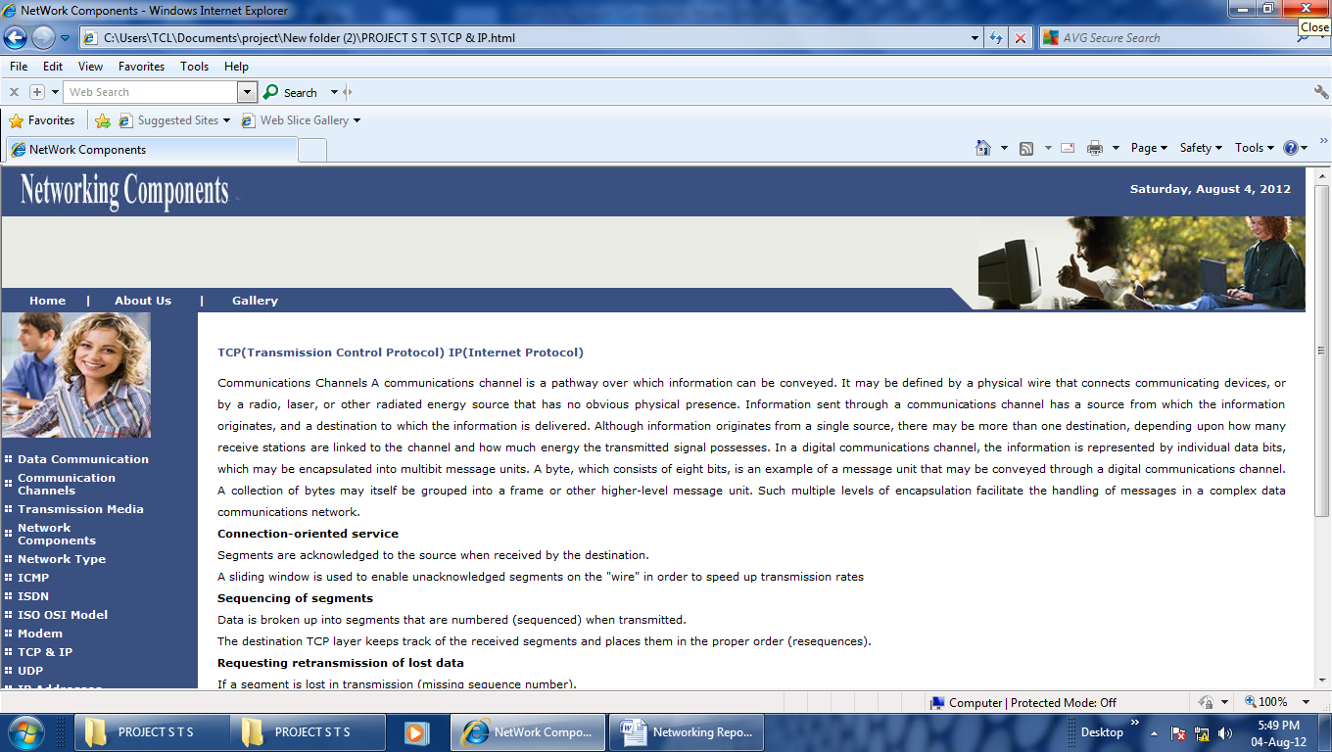

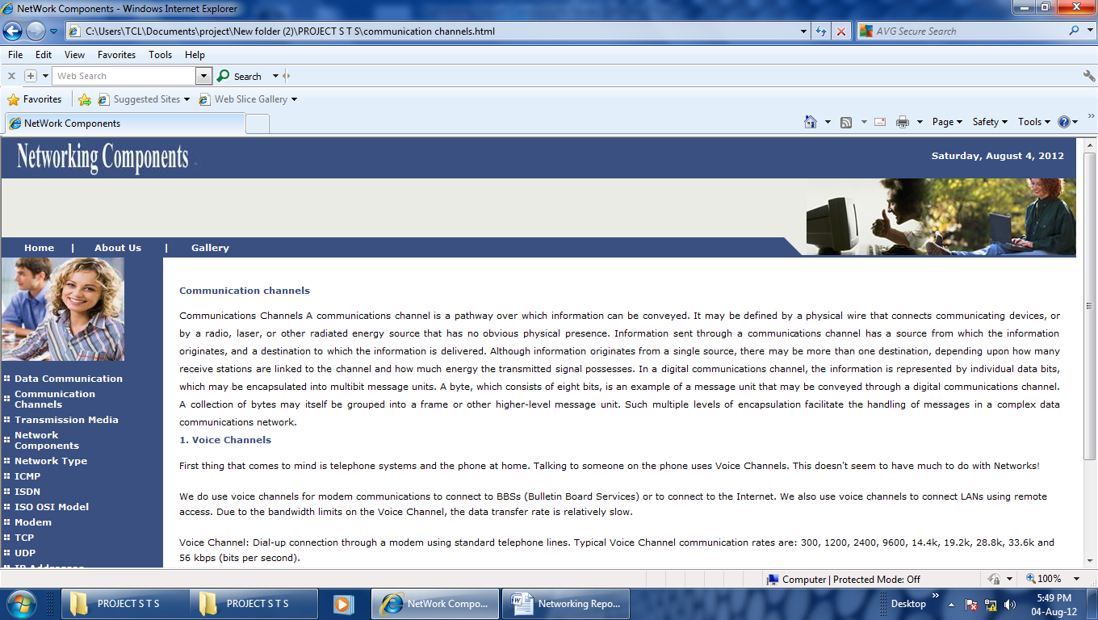

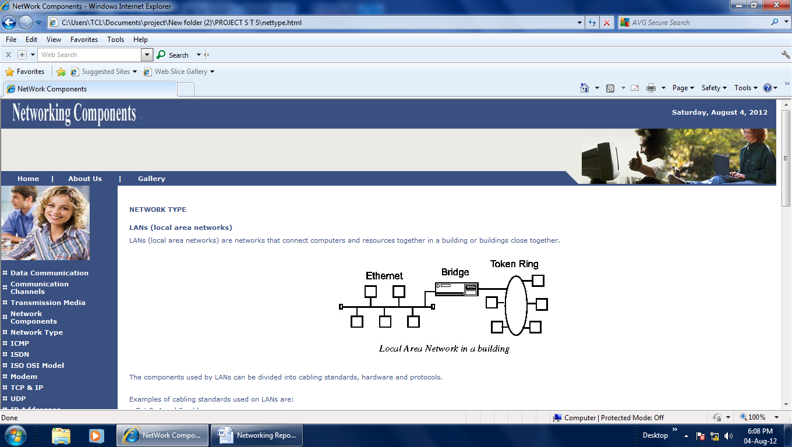

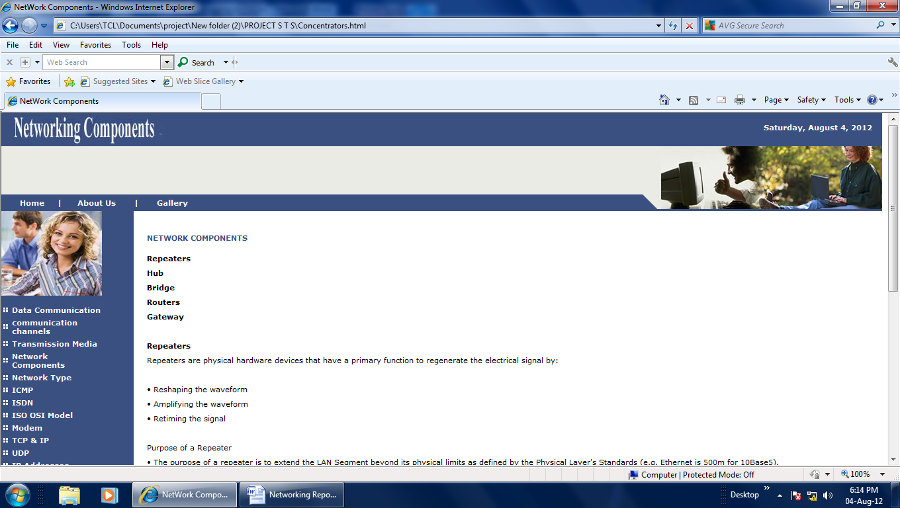

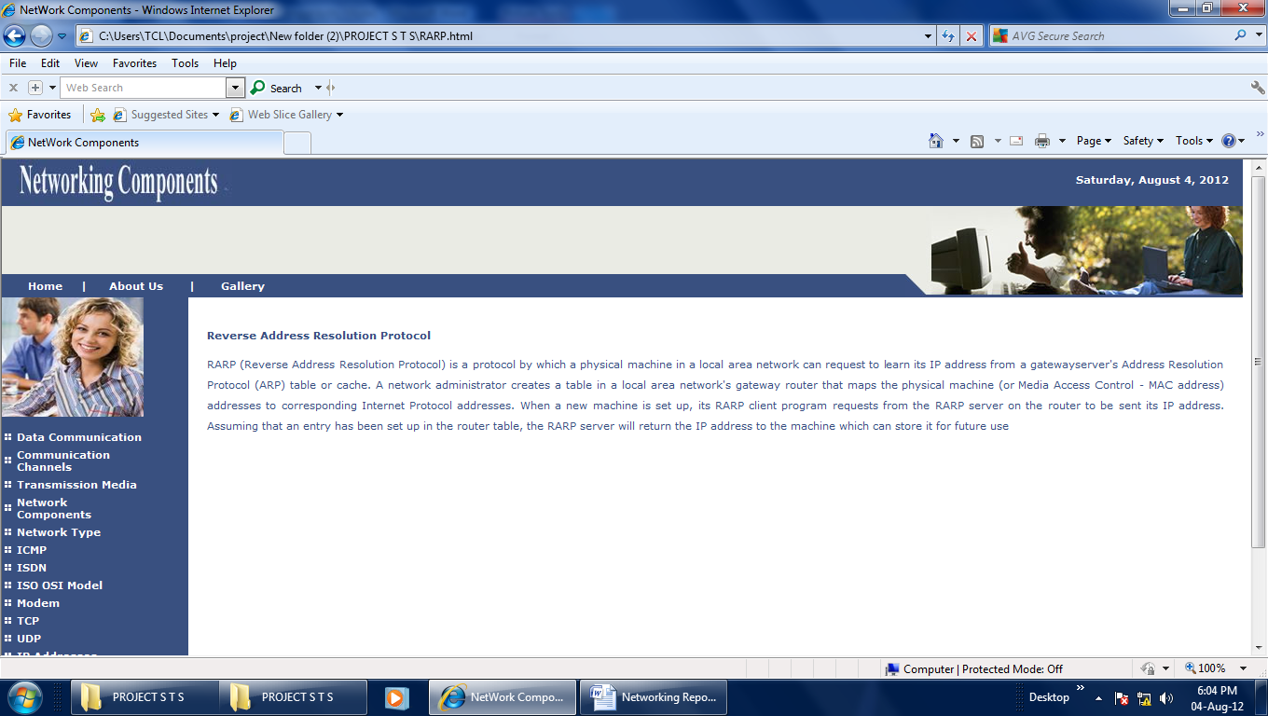

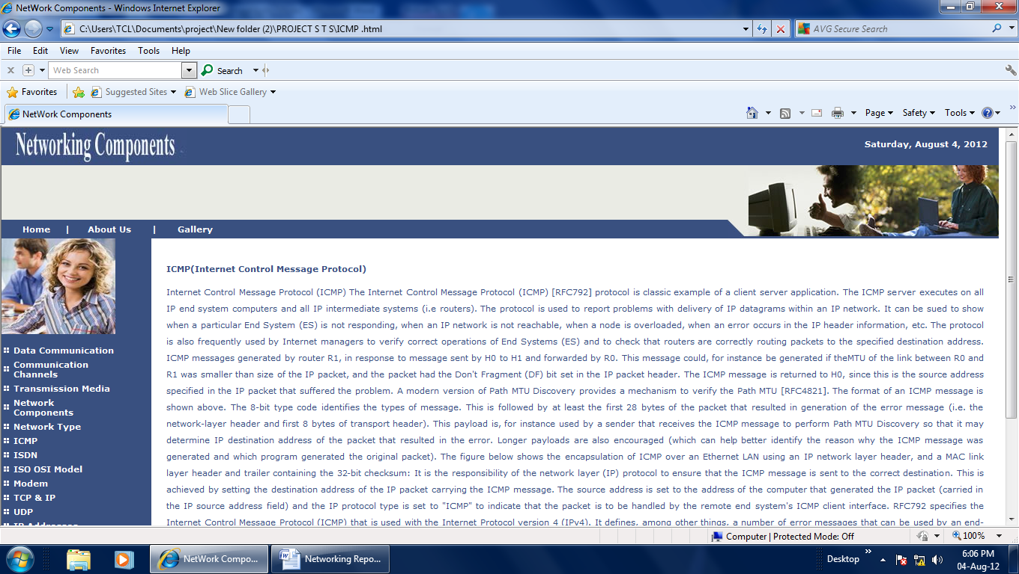

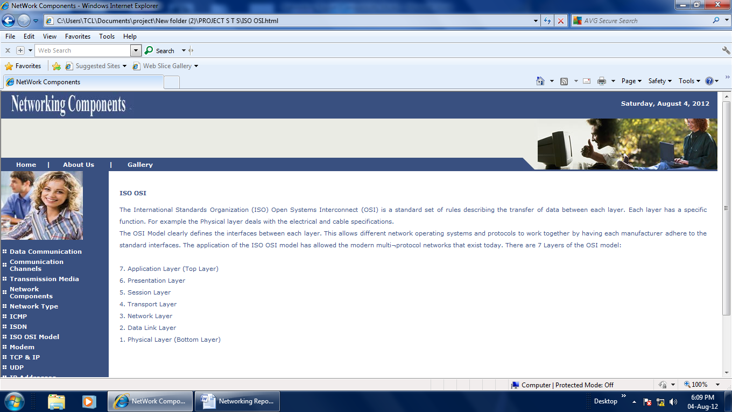

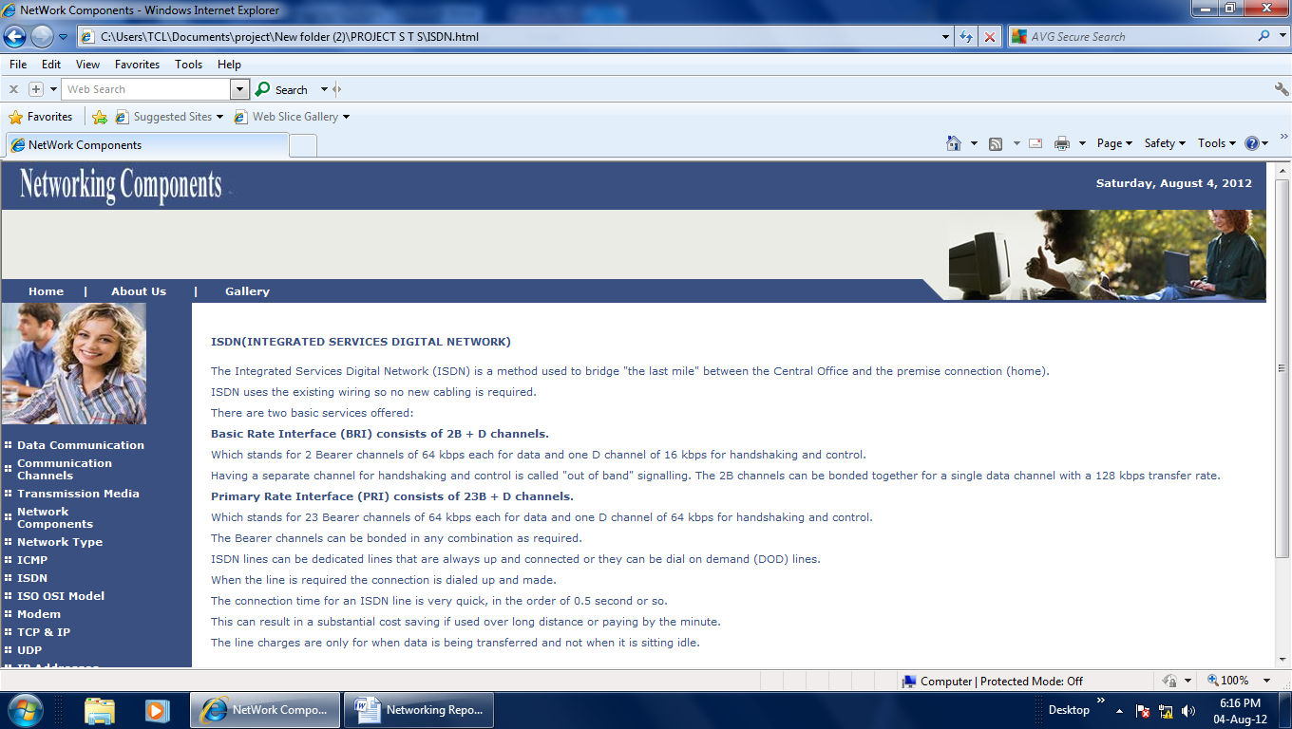 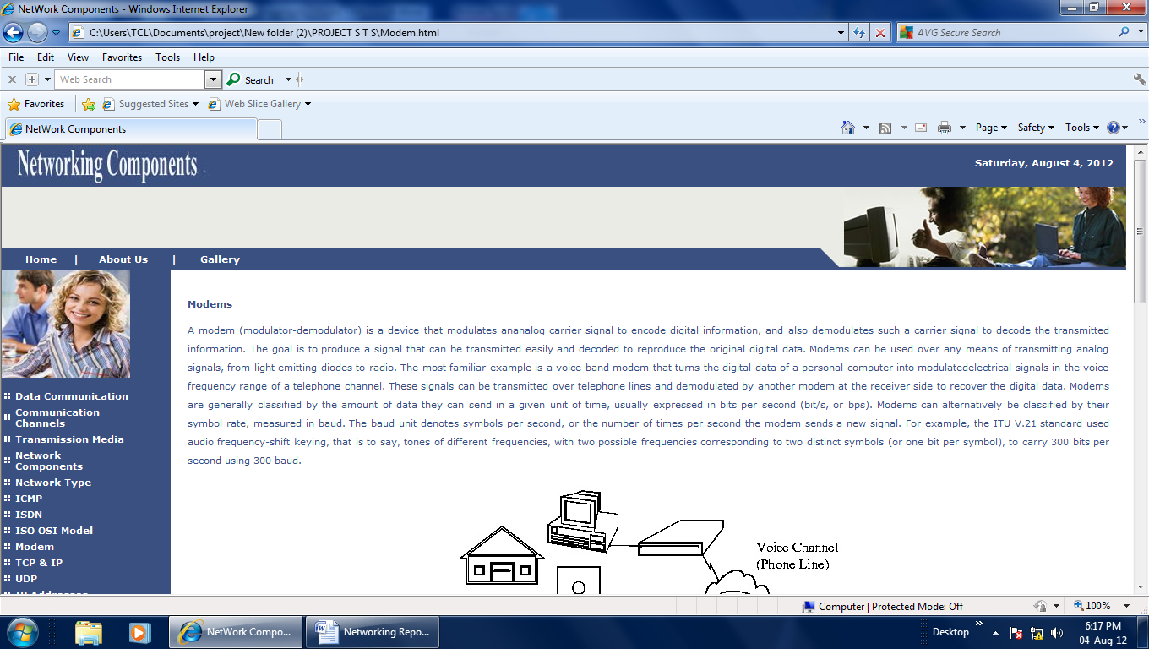

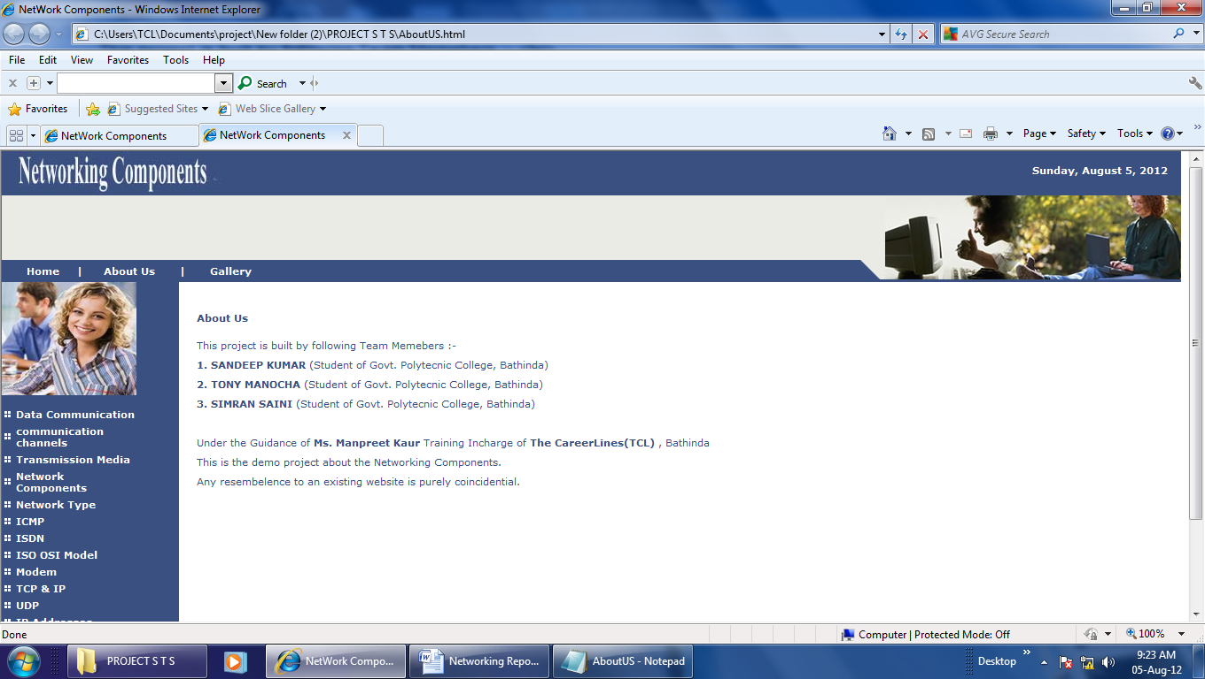

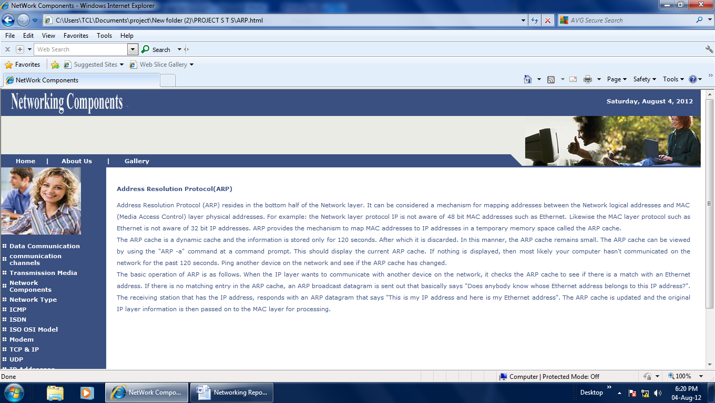

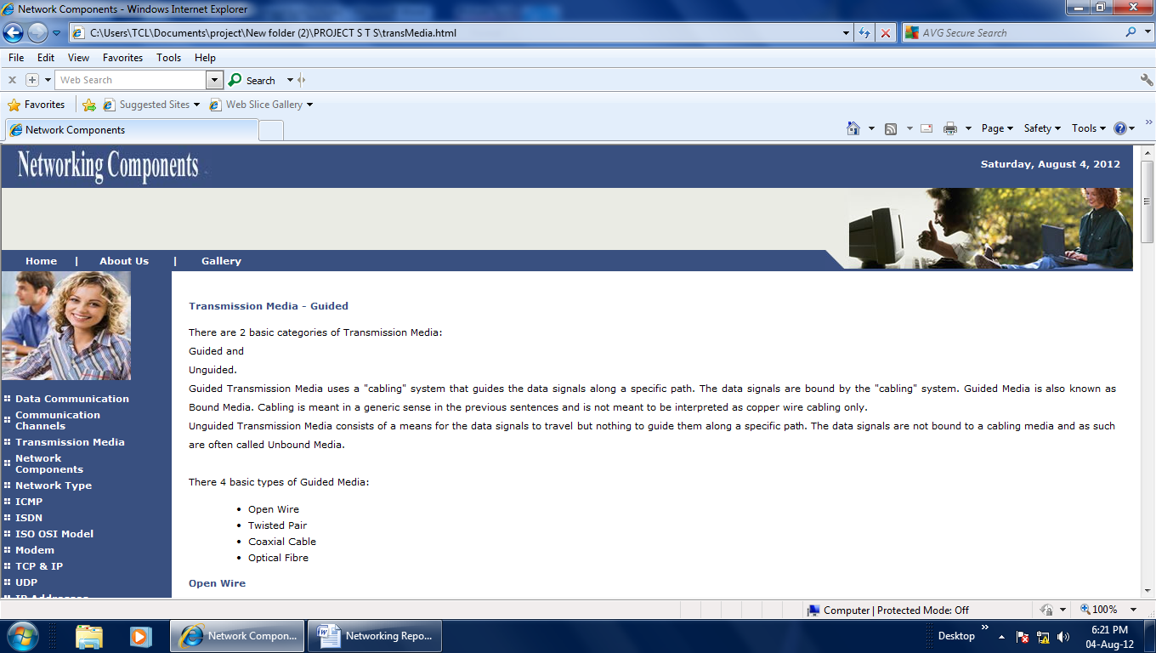

**Chapter: 9**

**BIBLIOGRAPHY**

**WEBSITES**

* [**www.yahoo.com**](http://www.yahoo.com)
* [**www.google.com**](http://www.google.com)

**BOOKS**

* **ISHAN’s Publication**
* **IPH**
* **Encyclopedia**